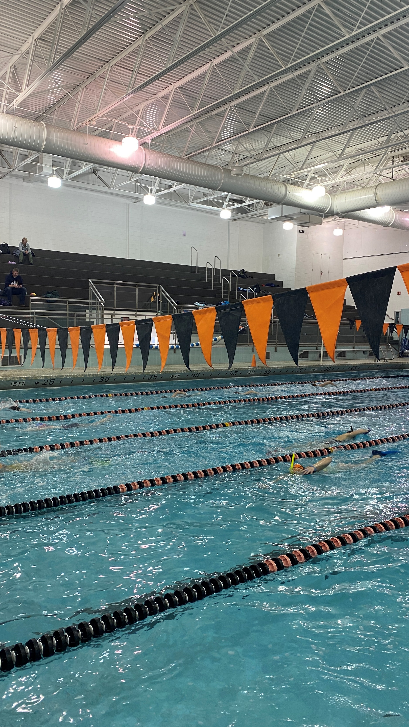

Championship Season Guide

March 2

Rockford Riptide Swim Team


Winter 2021-2022

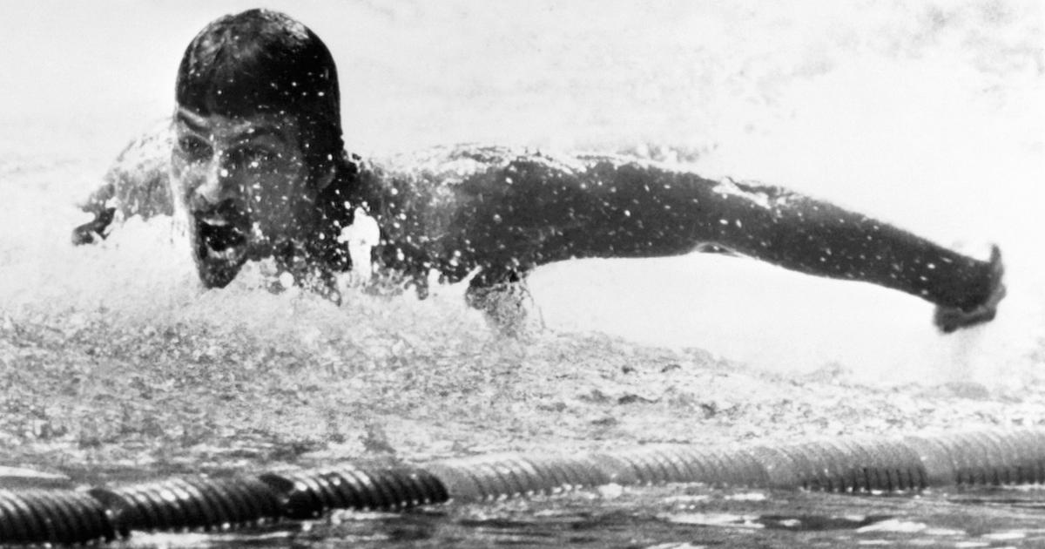
The Light at the End of the Tunnel

With one month to go, it’s time to focus in on that final meet.
It’s been a long season. It’s always cold out, there seems to never be any sunlight, and you’re tired every day. You may even be getting tired of coming to swim practice every night or putting up with the people in your lane. That’s normal, especially for a sport with a season as long as our sport’s. But luckily, we are almost there!

During this final month or so of your season, swim practice may start to look and go differently. After putting in all the hard work necessary for your training, this final section of the season is used to focus on making final preparations for your end-of-season championship meet: resting your body, final adjustments on the smallest details of your stroke, intaking the proper nutrition and hydration, and creating the proper mind space to achieve your goals.

“If you fail to prepare, you’re prepared to fail.”
-Mark Spitz, nine-time Olympic Swimming Champion

Taper Time, and the Livin’s Easy

Shorter practices mean more focus, and more energy.
Towards the end of the season, most swimmers will go through “taper,” a part of your season where the amount of yardage at practice goes down, but not the intensity. Reducing the yardage helps our bodies to be more fully rested for our championship meets, but we need to maintain the intensity of our workouts to make sure our muscles are still in shape.

During this “rest period,” your body’s maximal oxygen uptake, usually called “VO2 max,” increases, meaning your body can utilize more oxygen during intense exercise. Your body’s anerobic threshold also increases during this time, meaning it can more quickly clear the built-up lactic acid and hydrogen ions that short, intense exercise generates. This all means that we are training our bodies to swim faster for longer without having to rest, perfect for your final shot at a 500 Freestyle personal record!

The lower amount of work during taper also means that your muscles will build back better than they normally do during the season. When you work out, you are breaking down our muscles so they can recover and grow back stronger. During the season, we never really give your muscles enough time to fully heal back, which is why your muscles get sore and tired. The lower volume of work during taper allows your muscles to fully build back up and heal, which helps them to better utilize your energy and be explosive!

As Olympic Gold medalist Alyssa Anderson puts it, taper is “a time where you are able to let your body fully recover from all the hard work and training you've done leading up to that point. […] Taper is when you put it all together and really get tuned in for what you've been preparing for all season” (https://bit.ly/3H72ULT).

Less swimming means less energy spent swimming, which means more energy outside of the pool. But just because you suddenly have all this extra energy does not mean you need to spend it. The point of taper and resting is just that: resting. Resting your muscles so they can heal fully. Resting your body so you have all the energy you need for your final meet. Resting your mind so you can focus on going fast. It will be tempting to use your new free time and energy elsewhere, at the park or running around outside, but hold back and remember why we are resting in the first place.

That being said, taper can be a weird and even difficult time for a swimmer. There are many swimmers who, during taper, will start to feel sluggish or slow in the water, like their whole stroke just feels off. But then the next day they feel unstoppable! This is what some swimmers and coaches call “taper funk.” The solution? Remind yourself that you have put in the hard work necessary this season to swim your fastest, even if you do not feel like it at practice. Have confidence that your body is ready to go fast, and that you are ready to achieve your goals.

Some people feel their best the day before or of their big meet. Some people feel their fastest a few days or even a week before the meet. If you do not think you are in the right spot, talk to your coaches. Communication is your best tool during the final stretch of your season. Your coaches are always keeping a close eye on you, but they can only gather so much from up on deck. When you communicate with them how you are feeling, in the water and out, they can better adapt your training to get you where you need to go at the end of the season.

So, what should you be worrying about during taper practices? Nothing! Let your coaches do the worrying for you. The most important thing you can do during taper is focus on your swimming and pay very close attention to your body and what it is telling you. If it feels off, talk to your coaches about it. Taper is different for everyone, but communication is the key to a good rest period and swimming your fastest.

More Resources Related to Your Championship Season
- https://swimswam.com/11-things-to-remember-when-taper-starts/
- https://swimswam.com/4-ways-to-optimize-your-time-prior-to-a-championship-meet/
- https://www.swimmingworldmagazine.com/news/what-happens-to-your-body-during-taper/
- https://www.swimmingworldmagazine.com/news/the-ups-and-downs-of-taper-time/

Only YOU Can Prevent a Bad Swim

With less time in the pool, it is time to tighten your focus.
Your championship meet preparation doesn’t end when you leave the pool, it is now around you all day. To achieve your goals in the water, you need to think about and work toward achieving them both in AND out of the water. That includes focusing on your swimming at practice, managing your time appropriately, and ensuring your body is receiving the fuel it needs.

With so little time left in the season, the time has passed to radically change how you pull your arms through the water in butterfly, or switch to a six-beat kick instead of your normal four-beat in freestyle, or decide now is the time to learn how to pull off that pesky bucket turn. Practices are not the time to drastically alter your stroke, rather, practice should be spent focusing on the most minute details of your strokes and races and perfecting those details. Things you can look for include:
- Am I breathing out of my flip turns?
- Can I tighten my streamline any more?
- How many dolphin kicks am I doing off the wall?
- Am I breathing to both sides in freestyle?
- Where is my head position in backstroke?
- Am I catching enough water with my breaststroke pull?
Those are just a half-dozen examples of the thoughts that are going through your coaches’ heads every minute of every practice all season, and why they are always giving you feedback. Now it is your turn to look at your swimming and see what you are doing right or wrong, what needs to change, and how to change it. As NFL champion head coaching legend and championship-trophy namesake Vince Lombardi once told his athletes, “Practice does not make perfect. Only perfect practice makes perfect.”

During taper, you should be taking advantage of the most valuable resource you have: your coaches! Not only do they know what they are talking about when giving advice, but odds are they have been in your aqua-shoes before, going through the same process and dealing with the same feelings you are. If something does not feel right with your stroke, tell your coach! If you want to make sure your stroke looks correct, ask your coach! Confused as to why you are feeling slow, or your times are matching the ones in your head, say it with me now: TELL YOUR COACH! They are there to help you figure out how to swim the best stroke possible (which is also your fastest stroke, by the way).

But just as you are tightening your focus while in the water, you must also increase your focus while out of the water. Depending on your age and year in school, this could look different. For all swimmers, championship season means prioritizing your goals in the water whether you are in the pool, at school, or at home. Focusing on your championship meet means dedicating the proper time to finishing schoolwork (i.e. getting it done early and not early in the morning), getting enough sleep every night (and not staying up super late playing video games or watching movies with your friends), and making sure you are resting your body (i.e. not jumping around all night in the bleachers at a basketball game or taking up pickup football after school). Think about the responsibilities you have and the activities you partake in and how they can affect your body and, thus, your performance in the water.

Taper is all about priming your body to perform the very best it can, much like a racecar. The car may be in tip-top shape with four new tires and a fresh coat of paint, but its fuel is just as important if the driver wants a shot to win the race. The same can be said for your body and your race: make sure you are putting the correct fuel into your body in the lead-up to your championship meet. That includes leaning more toward healthier foods and away from snacks and treats. Below are some links to some helpful nutrition guides for swimmers. But food is not the only fuel your body uses, remember? Sleep is maybe the #1 thing you can do to prepare for your race. Make sure you are getting enough, and your body will thank you later.

More Information Related to Nutrition & Sleep
- https://www.yourswimlog.com/category/swimming-nutrition/
- https://www.youtube.com/watch?v=TMVTZRVZb4E
- https://youtu.be/z_vZ26fLWhs
- https://www.researchgate.net/publication/317561306_Sleep_improvement_in_athletes_Use_of_nutritional_supplements

Swim Like a Champion Today

Training your mind is just as important as training your body for success.
Even after all the preparation you have done this season to achieve your goals, none of it will matter if you are not in the right mindset to achieve them on race day. Your body being ready is one thing, having your mind in the right place to get it to do the right thing is another. That is why you need to have thought-out and achievable goals, know how to prepare your mind to swim fast, and how to motivate yourself to do what you need to do to succeed.

Setting a goal is easy: “I want to break the team record in the 100 Yard Freestyle.” But what does it take to achieve that goal? (“Uhhh, I don’t know.”) Is that goal helpful? (“Ummm…”) What are you going to do to achieve that goal? (“I don’t know, work harder?”) Setting goals for yourself is an important part of having an elite mindset, but they also have to be useful goals. When setting a goal or goals, the most elite athletes frame them in terms of being “S.M.A.R.T.” A SMART goal is one that is:
- Specific: What will be accomplished? What actions will you take?
- Measurable: How will you measure your success? How much? How well?
- Achievable: Is the goal doable? Do you have the skills and resources necessary?
- Relevant: How does the goal align with your other goals? Why is it important?
- Time-Bound: What is the time frame for achieving this goal?
Framing your goals around the SMART model will help you better understand what will need to be done to achieve them and ensure they are helpful in your growth as an athlete. Bad goal: “I want to break the team record in the 100 Yard Freestyle.” SMART goal: “I will take 2 more dolphin kicks and 0 breaths off every wall at practice this season.” Using SMART goals helps you to better guide your motivation and mindset to achieve your goals.

Another powerful tool in your arsenal is visualization, a technique of mental imagery, rehearsal, and meditation that helps to condition your brain to enable you to swim faster. Put simply, you daydream yourself achieving your goal, and when done consistently visualization can “hard-wire” a great performance in your brain. Since your brain cannot distinguish between real or imagined experiences, visualizing your success helps to train your body in much the same way your physical training does.

To maximize the results, your visualization should have a very specific, positive outcome while also being realistic. In this case, “realistic” concerns all the little details of your experience, including potential obstacles. There are a multitude of problems you could encounter on race day: a shortened warm-up, you’re the last one off the blocks, one of your goggles is slowly filling up, your counter for the 500 is off by a lap. Effective visualization will incorporate setbacks not to stress out the athlete or catastrophize race day, but to train the athlete to not stress out or catastrophize if something does not go according to plan. Through visualization, their brain should already be trained to respond to and work past said setback, because the athlete has gone through that in their head dozens of times before.

The more detailed your visualization, and the more consistently you visualize, the more effective the tool will be over time. Even the most minute details will help in your visualizing: engage all five senses, imagine the reactions of your coaches, teammates, and parents, and the joy you will feel when you achieve that goal. The most powerful tool an athlete has is their mind, use it.

More Information Related to Mental Training
Goal Setting:
- https://www.swimmingworldmagazine.com/news/smart-goal-setting-for-swimmers-its-a-process/
- https://swimswam.com/how-to-swim-faster-effective-goal-setting/
- https://www.yourswimlog.com/goal-setting-swimmers/
Visualization:
- https://swimswam.com/use-visualization-swim-like-boss/
- https://www.eatsleepswimcoach.com/swimming-visualization/
- https://www.youtube.com/watch?v=p-mZhvxeK_k
- https://www.youtube.com/watch?v=L5b-ggPlx-E

At the end of the day, it may only be you in the water, but that doesn’t mean you’re alone. You’ll be surrounded by your teammates, coaches, and loved ones, who all want nothing more than for you to achieve their goals. If you can remember that, and take care of your body and mind, you’ve got nothing to worry about when you step up on that block. Good luck!

